NAME: MD RABBANI

TEAM LEADER

ASSIGNMENT-1:

1.BAR CHART:

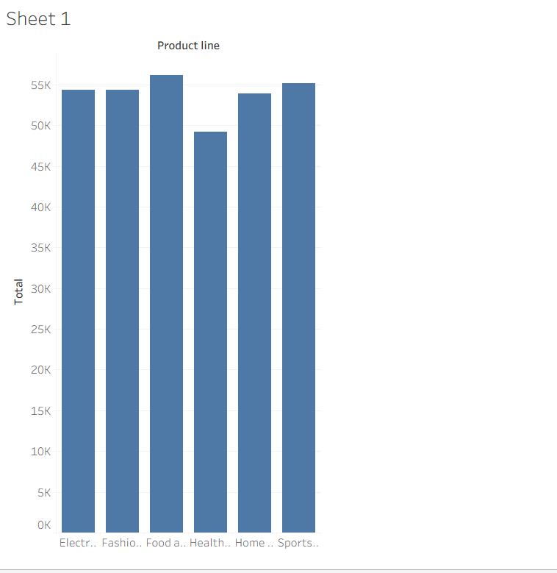

2.PIE CHART

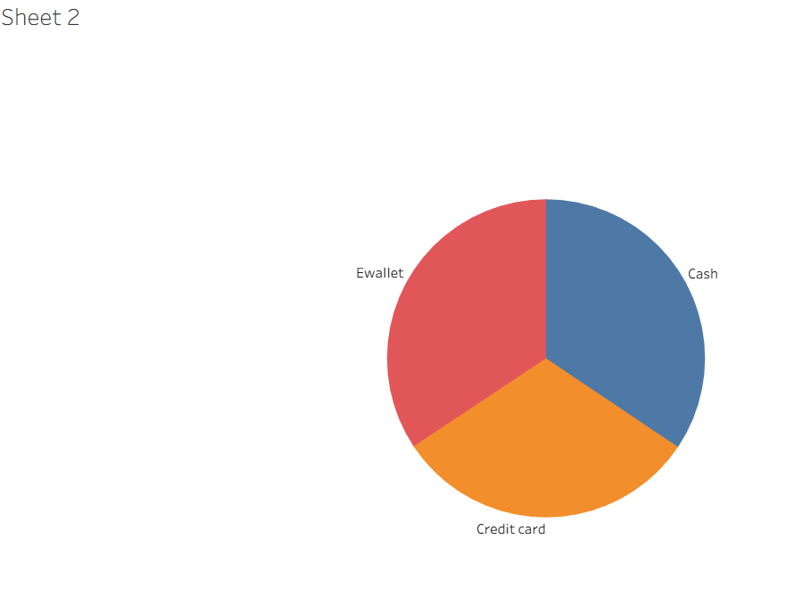

3.STACKED BAR CHART:

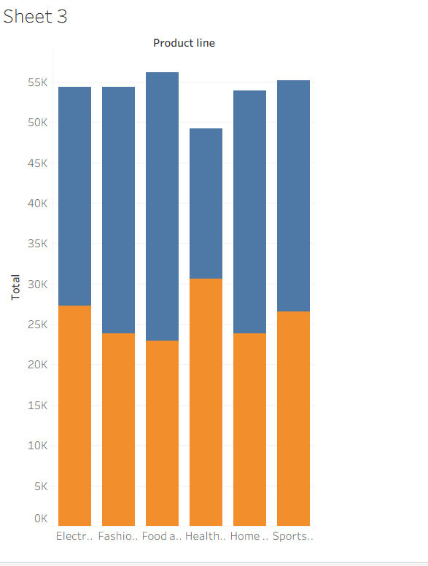

4.LINE CHART:

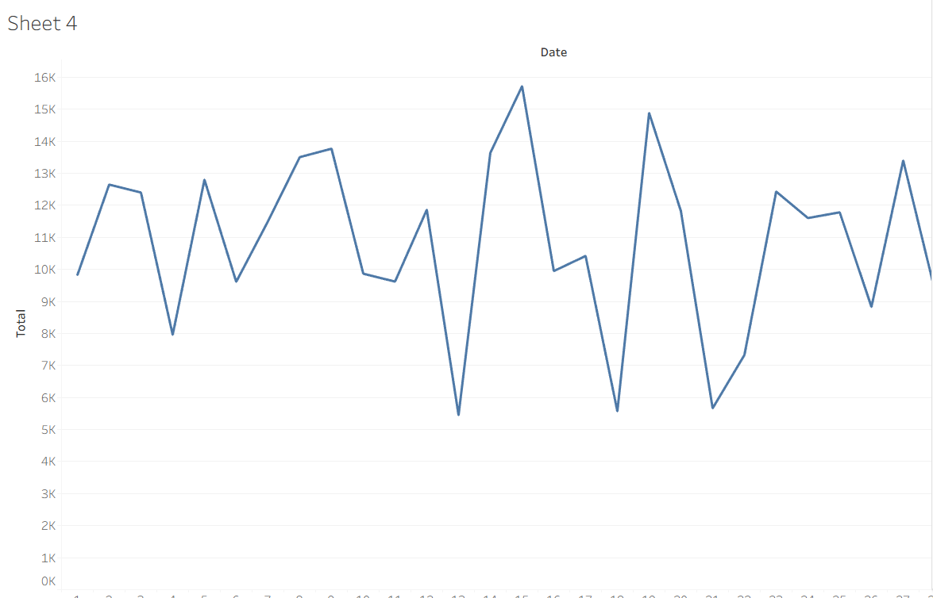

5.BUBBLE CHART:

